Title (Calibri 14, bold)
Author's Name¹ and Author's Name^{1, etc.} (Calibri 12, bold, line spacing: before 6 points, after 6 points))
¹Authors' affiliations (use complete addresses)

Keywords (Calibri 11, bold, line spacing: before 6 points, after 6 points)
conference; thermal analysis; Zakopane.
Introduction (Calibri 11, bold, line spacing: before 6 points, after 6 points)
Page margins should be 2.5 cm for top, bottom, right and left margins. Use font type Calibri (11 point), with single spaced lines.
Experimental (Calibri 11, bold, line spacing: before 11 points, after 6 points)
The experimental should contain two parts: materials and methods.
Results and discussion (Calibri 11, bold, line spacing: before 11 points, after 6 points)
The figure, table and their title should be centered according to the examples shown below.
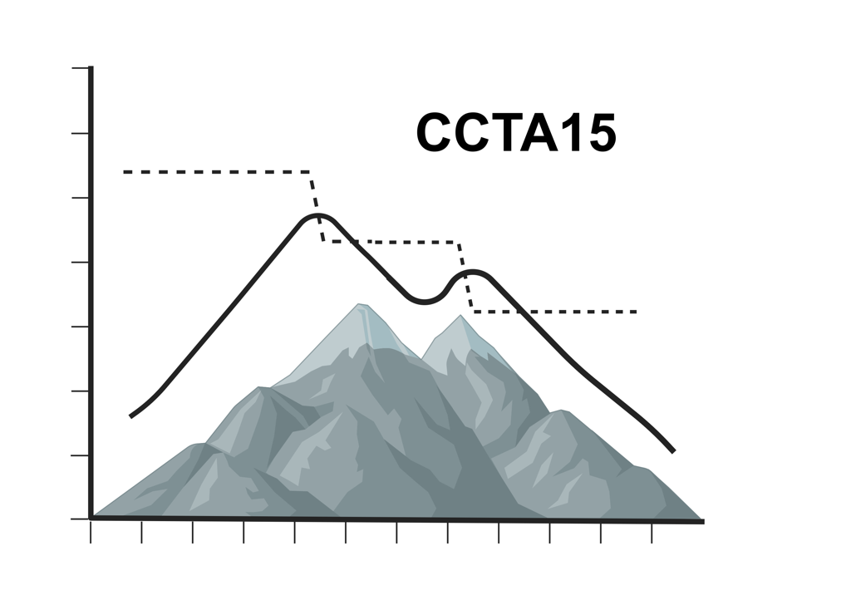
Fig. 1 Title.

Tab. 1. Title.
Conclusions (Calibri 11, bold, line spacing: before 11 points, after 6 points)
Conclusion should contain the major findings. highlight the major findings
Acknowledgement (Calibri, 11 point type, left aligned, bolded, italicized)
Acknowledgement (Calibri, 11 point type, left aligned, bolded, italicized)
References
- Author A.; Author B: Abbreviation of Journal Title, Year, Volume (Issue), Pages
- Author A., Tittle of the Book, Publisher, Year, Pages.

THE ABSTRACT SHOULD NOT EXCEED TWO A4 PAGES

